Heading: Kaufmann, Netrebko and Eyvazov - a stellar cast for Tosca 2024
Subheading: A spectacular cast will take the stage at the Arena Opera Festival 2024 for Giacomo Puccini's Tosca. The opera stars confirm their bond with Verona in a series of breathtaking performances, which will go on stage on 2, 9, 16 and 30 August. Tickets are already on sale for the four dates and for the entire 2024 Festival

After Anna Netrebko, Yusif Eyvazov and Luca Salsi were confirmed for the shows on 2, 9, 16 August, Fondazione Arena di Verona also confirms the presence of Jonas Kaufmann, Elena Stikhina and Ludovic Tézier for the last opera night, on 30 August.

Anna Netrebko returns as the star of the Arena di Verona And, for the first time, she will be Tosca for the first three opera performances. Her bond with the Roman amphitheatre and the city of Verona becomes deeper and deeper. She debuted in 2019, with three captivating performances as Leonora in Il Trovatore. Despite the challenges posed by the pandemic in subsequent summers, Netrebko has been a steadfast presence at the Arena Festival, embodying diverse characters each year. From headlining the 2020 Gala with pieces from Verdi, Cilea, Donizetti, and Giordano to playing Turandot in 2021 and taking on Aida and Turandot in 2022, she marked the opening and closing of the sold-out 100th Festival in 2023 as Aida and La Traviata, respectively. She will share the stage with her life partner, tenor Yusif Eyvazov (Mario Cavaradossi), and baritone Luca Salsi (Baron Scarpia), in the popular opera adaptation with direction, sets, and costumes by Hugo De Ana - a production seamlessly blending powerful symbols, sumptuous traditional costumes, rapid scene changes, and breathtaking effects.

DISCOVER 'TOSCA’

On Friday, 30 August , the immense stage of the Arena di Verona will host Tosca for its fourth and final performance of the 2024 Festival 2024, with an exceptional cast. Opera star Elena Stikhina - one of today's most popular sopranos - will return to the Amphitheatre, backed by her successful and much applauded Arena debut last year. Jonas Kaufmann will take on the role of Mario Cavaradossi - painter, revolutionary and Tosca’s passionate lover. The tenor from Munich, demanded for this role all over the world, will perform it for the first time at the Arena, confirming his bond with Verona and the Fondazione Arena. The famous trio will be completed by baritone Ludovic Tézier as the perfidious Baron Scarpia, chief of police, persecutor of revolutionaries like Cavaradossi, and burning with passion for the diva Floria Tosca - one of the most iconic antagonists in the entire operatic repertoire.

DISCOVER 'TOSCA’

Tosca: 2, 9, 16 August 2024
Yusif Eyvazov  Mario Cavaradossi | Anna Netrebko  Floria Tosca | Luca Salsi  Baron Scarpia
 | 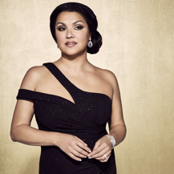  © 2023 Olga Rubio Dalmau | 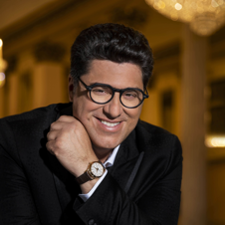  © Marco Borrelli
BIOGRAPHY | BIOGRAPHY | BIOGRAPHY

Tosca: 30 August 2024
Jonas Kaufmann  Mario Cavaradossi | Elena Stikhina  Floria Tosca | Ludovic Tézier  Baron Scarpia
© Gregor Hohenberg - Sony Music | 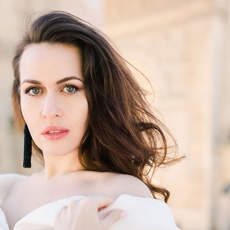  © 2023 Ksenia Paris | 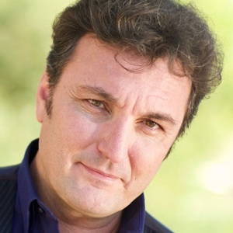  © Cassandre Berthon
BIOGRAPHY | BIOGRAPHY | BIOGRAPHY

The story of Floria Tosca, originally written by playwright Victorien Sardou for Sarah Bernhardt in 1887, captivated Giacomo Puccini, who entrusted the libretto to the skilled hands of Giacosa and Illica. The opera premiered in Rome in 1900 to resounding success, establishing Tosca as the quintessential diva of the operatic repertoire. Set in Rome in 1800 amid the conflicts between French revolutionaries and the power of the Pope King, the renowned singer Tosca witnesses politics and history upheaving her life and love in a gripping and musically revolutionary narrative akin to a pre-literary thriller.
Tickets are already on sale for all dates of the Arena di Verona Opera Festival 2024, from 7 June to 7 September, including 7 opera shows, 6 galas and 1 ballet.

DISCOVER 'TOSCA’

Box Office
Via Dietro Anfiteatro 6/B, 37121 Verona
biglietteria@arenadiverona.it - Call center (+39) 045 800.51.51
www.arena.it
TicketOne presale points

