PRESS RELEASE

FOLLOWING THE SOLD-OUT WORLD PREMIERE

“VIVA VIVALDI. THE FOUR SEASONS IMMERSIVE CONCERT" IS RECONFIRMED IN THE 2025 PROGRAMME

Great success for the show that revolutionises symphonic music, co-produced by Fondazione Arena di Verona and Balich Wonder Studio

Tickets now on sale for event of 27 August 2025

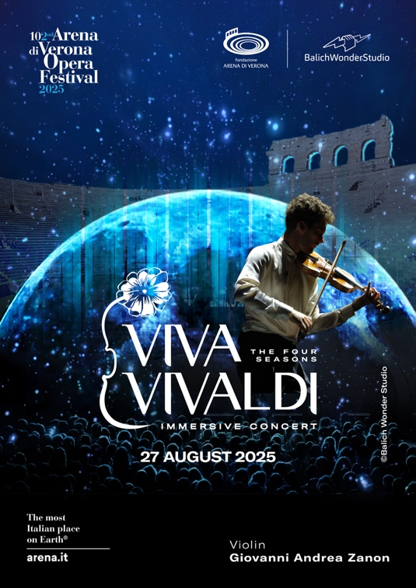

Verona, 1 October 2024 - The show dedicated to Vivaldi's Four Seasons, which enchanted over 10,000 people last August, will return to the Arena in 2025.

On 27 August, 2025, it will once again be possible to attend the show Viva Vivaldi. The Four Seasons Immersive Concert, co-produced by Balich Wonder Studio with Fondazione Arena di Verona. The show marks a revolution in symphonic music and confirms the success of a contemporary, technological and visual approach to the classical repertoire.

An audience amazed and captivated by the overwhelming power of music and images, welcomed Viva Vivaldi with a standing ovation, paying tribute to the talent of young Giovanni Andrea Zanon, violinist and star of the music scene, the concertmasters of the Arena di Verona, and the intuition of director Marco Balich who, with his team of internationally renowned Italian talents, has also thrilled new generations.

Alongside lovers of classical music, many young people have chosen the Vivaldi show, attracted by the technological and poetic fusion of music, images, lights and special effects and by the charm of the world's largest open-air theatre.

Tickets for the Viva Vivaldi show on 27 August 2025 are available on the website www.arena.it and from TicketOne.

Fondazione Arena di Verona
Fondazione Arena di Verona, one of the fourteen Italian Lyric-Symphonic Foundations, organises the most important open-air opera festival in the world. It takes place every summer in the Arena, the Roman-era amphitheatre that, together with the myth of Juliet and Romeo, has made Verona one of the most beloved and visited Italian cities. Every year, from the beginning of June to the beginning of September, the Arena hosts about 50 operatic, gala and concert performances, offering the most popular works of the repertoire, especially by Verdi. Since 1913, the year of its inauguration with Aida (primadonna opera of the Festival and since then repeated 749 times), the most established performers of the international scene have taken to the Arena stage to the delight of millions of spectators who continue to come from all over the world to feel like protagonists in this magical open-air space. For around fifty years, the Fondazione Arena di Verona has boasted a permanent artistic staff with orchestra, chorus, technicians and administrative staff of the highest levels. In addition to the Summer Festival, during the winter months it organises the Opera, Ballet and Symphony Seasons at the Teatro Filarmonico, in addition to concerts throughout the world at leading institutions, and exhibitions for young people, schools and enthusiasts.
Balich Wonder Studio
Balich Wonder Studio is one of the leading live entertainment groups that creates and produces live experiences, creating visionary projects with long-term value: from large-scale ceremonies to immersive shows, from brand events to experiences of transformation of the territory. Balich Wonder Studio's approach puts emotions at the forefront, through unique creativity and impeccable execution. Founded in 2013, the group relies on the talent and skills of a multicultural team that comprises over 280 people from 20 countries and operates in Europe and the Middle East.

Marco Balich
Marco Balich is one of the most eminent and innovative figures in the creation of large-scale live events. He has curated the production of 14 Olympic Ceremonies and countless major events around the world. For the Olympic Ceremonies of Turin 2006, he won an Emmy Award, while for those of Rio 2016 ADI awarded him the Compasso d'Oro. Marco Balich is also the creator of famous award-winning icons, including Whale Shark, a suspended icon created to mark the World Cup in Qatar in 2022, and the Tree of Life for Expo Milano 2015. He has created various innovative formats, including the show for Ghiaccio e Proiezioni Opera on Ice, Water Show with drones and fire on water in Doha in 2022, and the revolutionary immersive show "Michelangelo - The Sistine Chapel immersive show", created together with the Vatican Museums for record-breaking results in 2018 with 280,000 tickets sold.
Giovanni Andrea Zanon
He began studying violin at the age of 2. During his musical career, he has performed in some of the most prestigious venues in the world, including the Carnegie Hall in New York, the Teatro alla Scala in Milan, the Elbphilharmonie in Hamburg, the Teatro La Fenice in Venice, the Philharmonie in Paris, the Musikverein in Graz, the Smetana Hall in Prague, the Bayerische Staatsoper in Munich, the Festspielhaus in Baden-Baden, the Gran Teatre del Liceu in Barcelona, the Royal Opera House in Muscat, the Konserthuset in Stockholm and the Arena di Verona. He recently represented Italy in playing at the National Stadium in Beijing for the closing ceremony of the 2022 Olympics, broadcast to the world.

Press Office:

Fondazione Arena di Verona
Stefania Finetto – ufficio.stampa@arenadiverona.it
Firmina Adorno – firmina.adorno@gmail.com

Balich Wonder Studio
Federica Moscheni – federica.moscheni@balichws.com

